Project Performance Test

Date | June 2026
Team ID
Project Name | Strategic Product Placement Analysis
Maximum Marks

Model Performance Testing:
Project team shall fill the following information in model performance testing template.
S.No. | Parameter | Screenshot / Values
 | Data Rendered | “FMCG retail dataset with 52 records and fields such as Product Category, Price, Competitor Price, Promotion, Foot Traffic, Seasonality, and Sales Volume.”  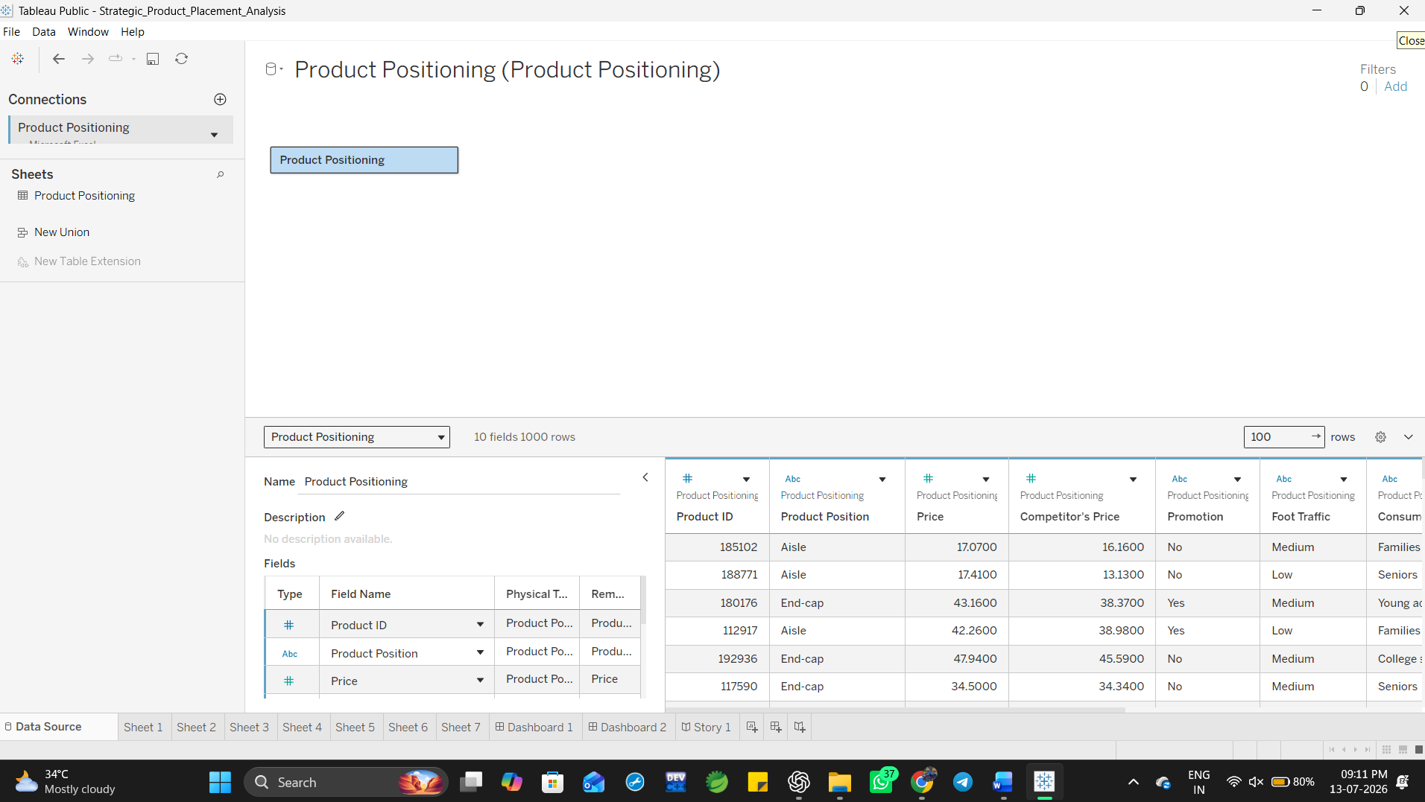
 | Data Preprocessing | “Verified data types, handled missing values, removed duplicates, and standardized category labels.”  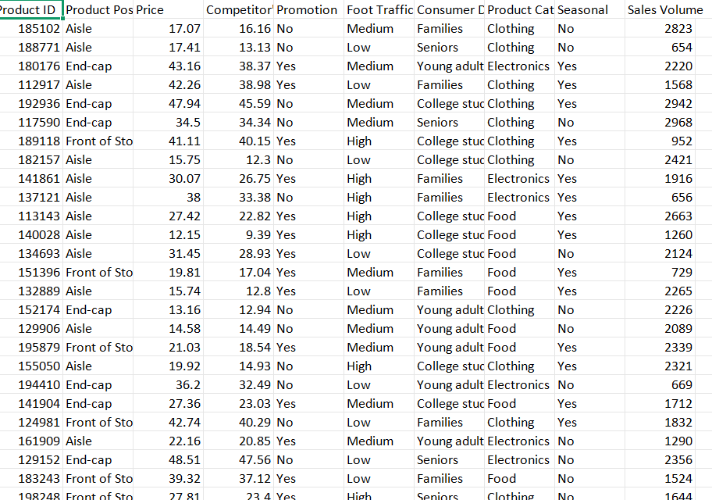
3. | Utilization of Filters | “Filters used: Product Category, Promotion Status, Foot Traffic Level, Consumer Demographics, and Seasonal Flag.”
4. | Calculation fields Used | “Calculated fields: Price Difference (Price – Competitor Price)  and Moving Average of Sales Volume.”
5. | Dashboard design | 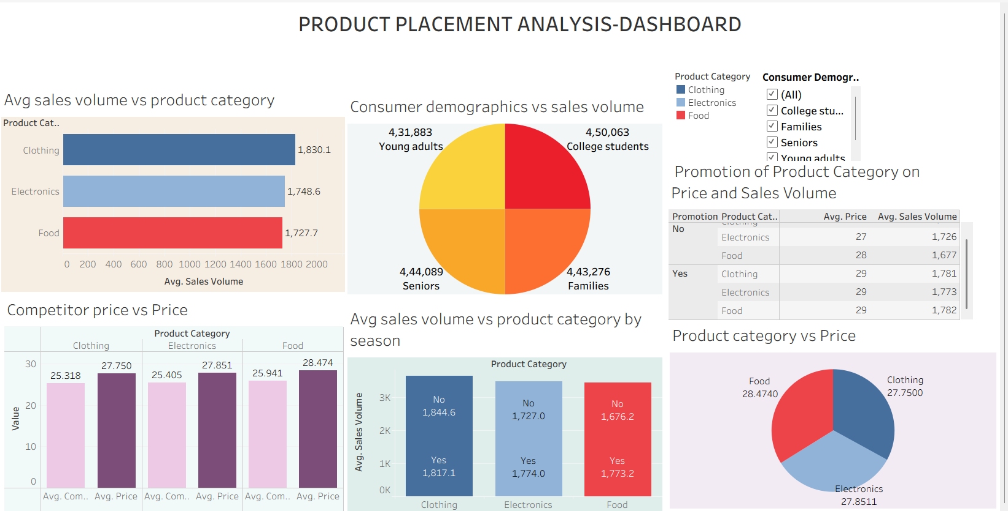
6 | Story Design | 